Award for Excellence
2020 Application

Submit applications to:

IMEC – Recognition Program
801 W. Main St. – Third Floor
Peoria, IL 61606
Attn: Holly Bender
– or –
Email application to: 1_Full_.i8gqpyhzys18fweb@u.box.com

Direct questions to:
Holly Bender
IMEC Recognition Program Manager
309.235.5204
hbender@imec.org

TABLE OF CONTENTS

How to Apply
- Basic Eligibility and Subunits 3
- Levels of Awards 4
- Is Your Organization Ready – Re-Application… 5
- Intent to Apply Eligibility Determination & Confidentiality 5
- 2020 Recognition Cycle Calendar 6
- Serving as an Examiner 7
- Fees 8
- Step 1 – Intent to Apply
  - Step 1.1 – Intent to Apply Instructions and Form 9 - 12
  - Step 1.2 – Applicant Profile Instructions 13
- Step 2 – Application Package
  - Application Report Instructions 14
  - Submitting the Application Package 15
Appendix
  - How to Order Baldrige Excellence Framework Booklets 16

HOW TO APPLY
ELIBILITY GUIDELINES

BASIC ELIGIBILITY
Eligibility for recognition is intended to be as open as possible; provided that an organization's major business functions are verifiable in Illinois.
Publicly or privately owned, domestic or foreign owned, joint ventures, incorporated firms, sole proprietorships, partnerships, and holding companies may apply. Subsidiaries of companies not headquartered in Illinois may be eligible if they meet the eligibility conditions contained in the Subunits and organization units section on pages 2 and 3.

AWARD ELIGIBILITY SECTORS
For 2020, the IMEC Awards for Excellence are available to Illinois organizations in the following sectors: Manufacturing, Service, Health Care, Education, Nonprofit and Government.
The eligibility sectors are as follows:
- Business- Organizations or Subunits that produce and sell manufactured products or manufacturing processes, which includes organizations in the agricultural, mining, or construction industries. Organizations in industry will use the business criteria booklet.
- Service - Organizations or Subunits that sell services. Proper SIC codes of organizations that perform both manufacturing and service are determined by the larger percentage of sales. Service organizations will use the business criteria booklet.
- Healthcare - Organizations or Subunits that provide services in the Healthcare sector. Health care organizations will use either healthcare criteria booklet.

- Educational Organizations - Institutions that provide educational services within the State of Illinois. Educational institutions will use the Education criteria booklet.

- Nonprofit or Government Organizations – Participation is open to Illinois based nonprofit public, private, and government organizations. For example, eligible organizations include local, state, and federal government agencies; trade associations; charitable organizations; social service agencies; credit unions; and professional societies. Nonprofit or government organizations will use the business criteria booklet.

SUBUNITS
For the purpose of the IMEC Awards for Excellence, the terms subsidiary, subunit, component, business unit, division, and district office are used interchangeably. A Small Business must apply as a whole business; Subunits of small businesses are not eligible.
A subunit is not eligible if its parent organization or one of its other subunits is the sole customer for its product or service. If the organization applying provides products and services internally (to a parent organization) and externally, then both activities need to be addressed in the Application Report.

Organizations performing only business support functions, such as sales, human resources, and legal services, are not eligible.
For a component of an organization to be eligible on its own, it must be considered an independently operated entity. This is defined as meeting all of the following criteria:

- It must have a clear definition of organization and mission, such as its own leadership and senior executives, administrative manuals or procedures, defined budget, accountability, etc.
- It must be sufficiently independent of its parent or peer organization in that it has authority to initiate actions, expend resources, and influence and affect the performance of most of the elements described in each assessment criterion and category, and that such elements can be evaluated without directly involving other organizations. For example, a field or regional office with the authority to spend budgeted funds on its own programs and initiatives; which engages in its own strategic plan (as part of the parent organization's plan); has some control over development of its work force; and is responsible for business results and customer relationship management, may apply separately if the other requirements of this part are met.
Note: This does not preclude an organization from applying if one or more of the services covered by an assessment criterion is performed by another organization, e.g., human resources, purchasing, etc. as long as the applying organization can use such services as part of its own quality and strategic decision making efforts. Neither is an organization ineligible if it receives policy direction and oversight from another organization. In all such cases, the evaluation will be based on consideration of all elements of the criteria, no matter where or by which organization they are performed.

- It must primarily serve the public or organizations other than the parent organization. For example, personnel, accounting, budget, procurement, and information services departments that provide service to the parent organization only, are not eligible to submit their own applications. However, forestry, public health, recreation, and streets and sanitation departments of local governmental units, all of whom serve the public, may be eligible to apply separately if the other requirements of this part are met. Similarly, an organization providing support services to other unrelated organizations may also be eligible.

- The organization is considered to be "permanent" (i.e., must have existed for one year prior to applying) and must not have a defined limited life.

LEVELS OF AWARDS

The IMEC recognition program provides a system for recognizing organizations at three levels that are representative of progress and growth toward performance excellence. Award levels reflect the increasing maturity of a performance management system as defined by the Baldrige Criteria for Performance Excellence.

All applicant organizations must submit an application responding to the criteria in a document not to exceed 50 pages. A team of Examiners will evaluate the applicant’s organization and develops feedback and findings. The Panel of Judges review these findings, select applicants for site visits, and recommend awards for applicants.

AWARDS FOR EXCELLENCE LEVELS:
IMEC BRONZE AWARD:
The first level of recognition is for the organization that demonstrates systematic approaches that respond to the basic requirements of the Criteria. A general improvement orientation is evident. Among the key approaches required to demonstrate a commitment to excellence are senior leaders’ actions to guide and sustain the organization, and the use of systematic approaches to improve key work processes. Results are reported for several areas that are important to accomplishment of the organization’s mission. Because deployment is a minimal factor in determining this award, site visits are not required.
Site visits for the Bronze award are subject to the judge’s determination.

IMEC SILVER AWARD:
The second level of recognition is for the organization that demonstrates effective, systematic well-deployed approaches that respond to the overall requirements of most Criteria Items and are aligned with organizational needs. Key approaches are beginning to be systematically evaluated and improved. Results are reported for many areas of importance and demonstrate improvement trends and/or good performance for some areas that are important to accomplishment of the organization’s mission.

Site visits for a Silver award are required.

IMEC GOLD AWARD:
The third level of recognition is for the organization that demonstrates effective, systematic well-deployed approaches that respond to the multiple requirements of most Criteria Items and are integrated to meet organizational needs. A fact-based, systematic evaluation and improvement process is in place to improve the efficiency and effectiveness of key approaches. Results are reported for most areas of importance, with beneficial trends in areas that are important to accomplishment of the organization’s mission, and performance relative to comparisons that demonstrates the organization is an industry leader in some key results areas. The organization can be considered a role model.

Site visits are required for a Gold award.

IS YOUR ORGANIZATION READY TO APPLY?
To decide if your organization is ready to submit an application, you are strongly encouraged to schedule an on-site “Application Writing Workshop” training session. This one-day workshop provides your organization the opportunity to further understand the IMEC Award for Excellence, the application process, and the Baldrige Criteria. It will assist your organization in getting started on writing an application, evaluating where you are in the organizational process, with tips and examples on how to get the most out of your application and understanding key points of the criteria in relationship to your organization. This workshop is HIGHLY recommended for all applicants both new and returning.
To schedule a workshop, contact Ben Krupowicz at bkrupowicz@imec.org

RE-APPLICATION
Organizations may reapply for an IMEC Award for Excellence in succeeding years and may be offered any one of the three levels based on the determination of the Judge’s Panel. Each award cycle is independent and awards are made without consideration of prior applications or awards offered.

INTENT TO APPLY AND ELIGIBILITY DETERMINATION
For organizations to participate in the 2020 Award Cycle an “Intent to Apply” Packet must be submitted to IMEC to determine eligibility (see page 10).
Potential Award Applicants should submit the completed “Intent to Apply” packet as early as possible, but it must be received by IMEC no later than March 27, 2020. Deadline extended to April 24, 2020.

The entire Application Package (maximum of 50 pages) must be received in the award office no later than May 22, 2020.

CONFIDENTIALITY
The names of applicant organizations and any evaluation findings, feedback or scoring information that is developed during the review of Applications are regarded as proprietary and kept confidential. Such information is available only to those individuals directly involved in the evaluation and Application distribution process. Members of the Board of Examiners are assigned to Applicants according to strict conflict of interest rules and receive no information regarding the content or status of Applications to which they are not assigned. Information on successful strategies of Award Recipients and other Applicants may be released only with written approval from the Applicant.

The IMEC staff will honor, to the fullest extent permitted by law, an Applicant's written request that certain information not be disclosed if the information is considered to be a trade secret or if its disclosure would damage the competitive position of the organization. It is suggested that the Applicant clearly mark information included in its application that it does not want disclose.

2020 Recognition Cycle Calendar

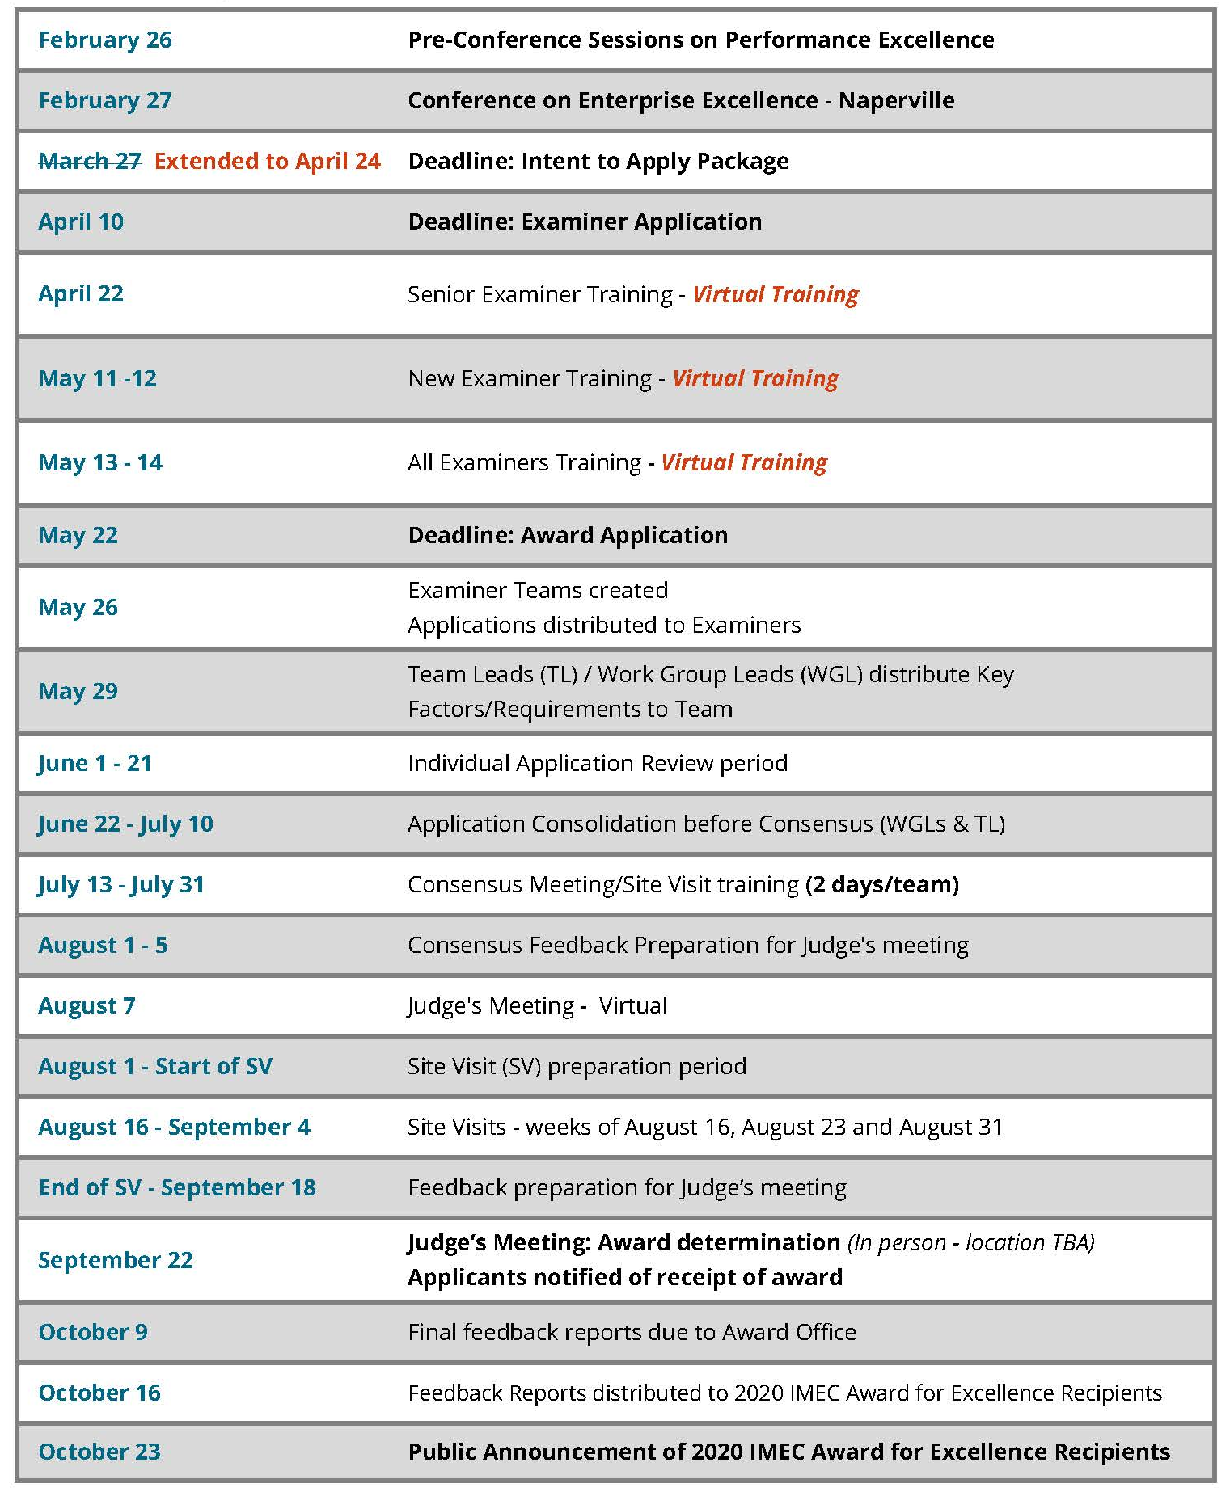

SERVING AS AN EXAMINER
Organizations often find it beneficial to encourage key members of their staff to serve as IMEC Recognition Program Examiners. For organizations or individuals interested in Examiner Training, the application to become an Examiner is available on the IMEC Recognition Program website at www.ilpex.org/examiner-information.
First time Examiners are required to pay a non-refundable fee of $1075 to attend training. This fee includes the two-day Criteria training, two-day examiner training, one-day site visit training/prep, and course materials.

Second year Examiners are required to pay a non-refundable training fee of $500 to cover the cost of materials and training.

Third year Examiners and beyond are not required to pay a participation fee.
Following is a timeline for those who wish to serve as an examiner.

Event/Status | Date
Complete Examiner Application | Due by April 10, 2020
Senior Examiner Training  *only required if requested to attend by the IMEC Recognition Program | April 22, 2020  Senior Examiner Training  Training will be virtual
New Examiner Training  *Returning examiners may attend for refresher training | May 11-12, 2020  Downers Grove (Hosted by Elkay Manufacturing) Training will be virtual
Two-day Examiner Training (ALL examiners must this session) | May 13-14, 2020  Downers Grove (Hosted by Elkay Manufacturing) Training will be virtual

FEES
Application Fees | Step 1 - Intent to Apply (see table below)  Step 2 - Application Package (see table below)
Site Visit Expenses | Award applicants may be granted a site visit based on the determination of the Panel of Judges. The fee for a site visit is $1500 and is due one week after the site visit ends. Each applicant is responsible for actual travel-related expenses for examiner team, including hotel, meals, and mileage (or car rental if cheaper), bus/train fare, and parking fees. Hotel and conference room accommodations for the site visit team should be booked directly by the applicant and coordinated with the IMEC office. A typical site visit lasts between three and five days and involves a site visit team of between four and eight people. IMEC will strive to keep expenses as low as possible and will coordinate and submit all expenses in a timely manner.

Organization Type or Size | Non-Refundable  Intent to Apply Fee | Application Fee | Site Visit Fee | Total Cost to Applicant
Large (over 1,000 employees) | $4,000 | $9,500 | $1,500 +  Actual expenses | $15,000  Plus actual site visit expenses
Regular | $4,000 | $7,500 | $1,500 +  Actual expenses | $13,000  Plus actual site visit expenses

DOCUMENTATION AND SITE VISIT DETAILS
Action | Award for Excellence application requirements
Applicant Profile | 5 pages maximum
Application Page Limit | 50 pages maximum
Site Visit | At Judges’ discretion

ELIGIBILITY AND INTENT TO APPLY PACKAGE

STEP 1.1 - INTENT TO APPLY INSTRUCTIONS AND FORMS

GENERAL INSTRUCTIONS
Before an Application for Awards can be considered, an “Intent to Apply” package must be received by March 27, 2020. Deadline extended to April 24, 2020. The forms may be downloaded from the IMEC Recognition Program website (www.ilpex.org) or may be duplicated and submitted as single-sided pages.

INTENT TO APPLY CHECKLIST:
The following items need to be included in your “Intent to Apply” packet:
  - Completed Intent to Apply Form (below)
  - Applicant Profile (5 pages maximum)

INTENT TO APPLY FORM
Item 1. - Applicant – Provide the official name and mailing address of the organization applying for the Award. |  |  |  | 1. Applicant  Organization Name Address Federal Employer Identification No. (FEIN)
Item 2. - Official Contact – Give the name, address, and telephone number of the official with authority to provide additional information or to arrange a site visit. If this official contact point changes during the course of the application process, please inform the Award Office. Please provide a contact number for this designee during the months of MARCH 2020 – JANUARY 2021. |  |  |  | 2. Official Inquiry Point  Name  Title  Mailing Address Overnight Mailing Address Telephone No. Fax No.  E-mail Address:
Item 3 – Criteria Information – Indicate which criteria you will be using to complete the application. |  |  |  | - 3. Check the Criteria booklet you are using (check one):  □ Business/Government/Non-Profit □ Education □ Health Care
Item 4. - Award Category – Select the appropriate award category based on the Applicant’s size and the sector in which it operates. |  |  |  | - 4. a. Award Category (check one):  □ Business □ Service □ Health Care  □ Education □ Nonprofit □ Government
If the Applicant is an educational institution, also indicate the category that best describes the institution. |  |  |  | b. For Educational Institutions only, Type of Applicant  □ K-12 School District □ Elementary School □ High School  □ Middle School/Jr. High □ Private K-12 □ University  □ Community College □ Technical School □ Pre-School  □ Independent College □ College/School in a University
Item 5. - Highest Ranking Official – Provide the name, title,  mailing address, and telephone and fax numbers of the Applicant's highest ranking official. |  |  |  | 5. Highest Ranking Official  Name  Title Address Telephone No. Fax No.
Item 6. - Size of Applicant – Give the estimated number of employees (and students, if applicable) of the applying unit as of the date the application is submitted.  Check the appropriate sales/taxes/ budget range for the preceding fiscal year. (The Applicant is reminded that all information is confidential and a range is requested simply to provide an appropriate perspective for the examiners.) |  |  |  | - 6. Size of Applicant  - Total number of employees No. of students  - Revenues (e.g., sales, taxes and/or fees collected, budget) for the pre- ceding fiscal year (check one)  □ 0 - $10M □ $11M - $100M □ $101M- $1B  □ $1M - $10M □ $100M - $500M □ Over $1B
Item 7. - Subunit Designation – If the applying organization is a component of a larger organization, information about the parent organization and its highest official must be supplied. |  |  |  | - 7. Subunit Designation (check one):  Is Applicant a unit, division, or like component of the parent organization?  □ No (go to Item 10) □ Yes (Continue)  Parent Organization Address Highest Official of Parent Organization  Title Telephone No. Fax No. Number of Employees Website address
Also provide the number of employees in the parent organization and the percentage of business transactions (e.g., sales, budget, and employees) or, for educational institutions, the number of students, as compared to the parent organization. |  |  |  | Percent of Business Transactions (or, for educational institutions, the number of students) as compared to Parent Organization Transactions (or the number of students)
Provide documentation detailing the parent's relationship to the subunit. |  |  |  | Describe the parent’s relationship to the subunit. Use separate sheets, if necessary.
Item 8. - Description of Applicant's Business – Describe the types of products and services provided by the Applicant, an organizational chart, and an Applicant Profile. Requirements for the Profile are described on page 13. |  |  |  | - 8. Description of Applicant's Business (Use separate sheets, if necessary.)
 | Item 9. - Non-Refundable Fee –See the fee schedule on page 8. |  |  |  | - 9. Fee (see instructions)  Enclosed is $ to cover the Intent to Apply Fee. Make check or money order payable to: IMEC
 | Item 10. - Release Statement – Please read this section carefully. A signed application indicates that the Applicant agrees to the stated terms and conditions. |  |  |  | - 10. Release Statement  We understand that members of the Board of Examiners will review this application. If a Site Visit is required, we agree to host the Site Visit and to facilitate an open and unbiased evaluation. We understand that Site Visit expenses will be due one week after the site visit ends in accordance with the Site Visit Expenses section on page 8.
 | Item 11. - Authorizing Official – The signature of the Applicant's highest ranking management official or designee is required, and indicates the Applicant will comply with the terms and conditions stated in the document. |  |  |  | - 11. Signature of Authorizing Official  Date  Name  Title  Address  Telephone No. Fax No.  Signature  E-mail Address:
 | Item 12. – Site Visit – Please select two weeks for potential site visit . |  |  |  | - Site Visit Selection – select by week  1st Choice:  □ August 16  □ August 23  □ August 30  2nd Choice:  □ August 16  □ August 23  □ August 30
 | Please make sure that all top executives will be available during the week of the site visit
 | Item 13. - Eligibility Determination – The Award Office approves or disapproves eligibility and notifies the applicant by phone and by letter. |  |  |  | 13. Eligibility Determination. For official use only.

STEP 1.2 – APPLICANT PROFILE INSTRUCTIONS

The Importance of Your Organizational Profile Your Organizational Profile is critically important because:
- it is the most appropriate starting point for self- assessment and for writing an application;
- it helps you identify potential gaps in key information and focus on key performance requirements and results;
- it is used by the Examiners and Judges in application review, including the site visit, to understand your organization and what you consider important; (you will be assessed using the Criteria requirements in relation to your organization’s environment, relationships, influences and challenges, as presented in your Organizational Profile); and
- it also may be used by itself for an initial self- assessment. If you identify topics for which conflicting, little, or no information is available, it is possible that the Organizational Profile can serve as your complete assessment, and you can use these topics for action planning.

Page Limit
The Profile is limited to five (5) pages. These are not counted in the overall application page limit which has a maximum of 50 pages. Typing and format instructions for the Organizational Profile are the same as for the application (see page 19).

APPLICANT PROFILE REPORT INSTRUCTIONS

Complete your Organizational Profile by responding to the questions in the Baldrige Framework booklet under the section labeled “Preface: Organizational Profile.

These include:

  - Organizational Description
    - Organizational Environment
    - Organizational Relationships

Organizational Situation

    - Competitive Environment
    - Strategic Context
    - Performance Improvement System

The Organizational Profile is a snapshot of your organization, the KEY influences on HOW it operates, and your competitive environment.
STEP 2 – APPLICATION PACKAGE INSTRUCTIONS

THE APPLICATION REPORT

Objective
The Application Report allows Award Applicants to provide information on quality management of products, programs, and services and on results of continuous improvement processes. The Board of Examiners evaluates the information provided in the Application Report against performance excellence criteria.

Instructions
The purpose of this section is to provide Applicants with instructions for preparing the Application Report. These instructions include information on typing, page limits, organization, assembly, and other format considerations.
Guidelines for responding to the application criteria are also given.

Requirements
Each Applicant must submit an electronic PDF Application Report consisting of:
- profile of the Applicant's organization (also submitted with Intent to Apply Package);
- responses to the Award Criteria.

FORMAT OF THE APPLICATION REPORT

Organization of Responses to Items and Areas to Address
The Award Criteria used to prepare the Application Report is provided in the 2019-2020 Baldrige Excellence Framework (Business/Nonprofit), Baldrige Excellence Framework (Education) or Baldrige Excellence Framework (Health Care). See the Application Appendix for ordering information.

The Application Report must:
- contain the same numerical and alphabetical designations for Categories, Items, and Areas to Address as the Award Criteria. (Applicants should denote responses to Areas by underlining [e.g., 4.2a.] and/or using bold type for Item/Area);
- respond to the set of Areas to Address in the order given to facilitate review by the Board of Examiners;
- if an Area does not pertain to the Applicant's organization or quality system, include a one or two sentence statement explaining why the Area is not applicable;

Formatting Instructions
The Application Report must:
- be formatted as standard, 8-1/2 x 11 inch size in a Times New Roman font of 10 point minimum; and
- use two-column, portrait double-sided pages. Type on pages (including pictures, graphs, figures, data tables, and appendices) must also meet these requirements for size and spacing.

Page Limits
The Application should not exceed 50 pages.
Note: Pictures, graphs, figures, data tables, and appendices are counted as part of the page limitations stated above and should be placed as close as possible to the related narrative (all graphs, data tables, and figures should be legible).
The use of separators, and glossaries of terms and abbreviations is helpful. In all cases, overviews, dividers, covers, glossaries, title page, and table of contents are not counted as part of the page limits.

Page 14

SUBMITTING THE APPLICATION PACKAGE

(Please read this section very carefully)

Document Assembly
A complete IMEC Award Application Package includes the following components in electronic PDF format:
- Front Cover – Blank (no text, pictures, or figures)
- Title Page (Text, Pictures and logo)
- Labeled Divider Pages (please do not add information about your organization here)
- Table of Contents
- Intent to Apply form and Description form
- 2020 MEC Award Eligibility Confirmation Letter
- Organization Chart (s)
- Glossary of Terms and Abbreviations
- Organizational Profile
- Application Report (responses addressing ALL Criteria items)
- Application Fee

All applicants must send one electronic PDF version of the Applicant Profile and Application Report.

Please mail check (payable to IMEC) for application fee to:
IMEC – Recognition Program
1501 W. Bradley Ave
Peoria, IL 61625
Attn: Emily Lee

– and –

Please email electronic copy (PDF preferred) of materials/application to:
1_Full_.i8gqpyhzys18fweb@u.box.com

Page 15

APPENDIX

HOW TO ORDER THE 2019-2020 BALDRIGE EXCELLENCE FRAMEWORK

The Baldrige Performance Excellence Program has released the 2019-2020 Baldrige Excellence Framework (Business/Nonprofit) the 2019-2020 Baldrige Excellence Framework (Education) and
2019–2020 Baldrige Excellence Framework (Health Care). All three versions include the Baldrige Criteria for Performance Excellence, core values and concepts, and guidelines for evaluating your organization’s processes and results.
Revisions to the Baldrige Excellence Framework, as with previous editions, aim to reflect the leading edge of validated leadership and performance practice.
The 2019-2020 Baldrige Criteria feature a renewed focus on

- Characteristics of your organization’s culture added
- Managing your supply network and business ecosystems
- ‘Requirements’ are now ‘Questions’
- Leading and managing in the context of your business ecosystem
- Enabling an aligned, collaborative, and agile supply network
- Creating and reinforcing your organizational culture
- Broadening your cybersecurity focus to include operations, workforce, customers, suppliers, and stakeholders

The 2019-2020 Baldrige Excellence Framework is $30 for printed copies (available from ASQ) and $12 for PDF copies (available from NIST, which houses the Baldrige Program). Volume discounts are available for bulk orders of both printed copies and PDFs. Enterprise licenses are also available; if interested, contact the Baldrige program at baldrige@nist.gov (link sends to email) or 301-975-2036.
In addition, the Baldrige Program released the 2019-2020 version of the companion product to the full Framework, the Baldrige Excellence Builder. PDF versions are available on the Baldrige Program’s website, and printed copies are available for purchase from ASQ. The Excellence Builder contains key questions for improving your organization's performance. It also provides an introduction to the Baldrige framework and can be used to conduct a self-assessment against the most important requirements of excellence.
Whether used as guidance in establishing an integrated performance management system or for self-assessing progress, Baldrige is about helping your organization innovate and improve, no matter its size or sector.

Page 16

