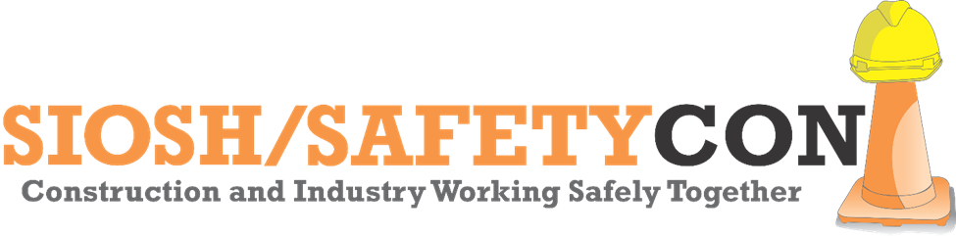
Nomination Form

SIOSH/SAFETYCON AWARD FOR CONTRIBUTIONS IN HEALTH & SAFETY

Award to be Presented at the Annual SIOSH/SAFETYCON Day Conference on January 27, 2020

Nomination Forms Accepted Through December 31, 2019, by Submitting to:

Lori Amerman, IMEC
SIOSH/SAFETYCON DAY Planning Committee
lamerman@imec.org

General Information
Name of Organization

Contact Name

Contact Phone

Contact Email

Brief Description of
Organization Nominated

Injury & Illness Rates
Year | Employee Hours Worked | Total # of OSHA Recordable Cases | Total # of OSHA Recordable Cases Involving Days Away from Work, Restricted Activity, or Job Transfer
2018

2019

Total

Leadership & Contributions
Briefly Explain Leadership and Contributions to the Workforce and Safety & Health Community

(Support of Stand-Downs, Initiatives, VPP, Participation in Alliances, Professional Memberships, Association Memberships, Publications, Presentations, Mentoring, Committee Participation, Conference Attendance, etc.)

Regulatory Violations
Has the Nominated Organization Had Any
Regulatory Violations Over
the Last 12 – 18 Months?

If so, Briefly Explain

Safety & Health Program Practices
Core Elements | Attach a Brief Description  (Examples May Include)
Management Leadership &  Employee Involvement | - Senior Leadership Commitment  - Written Safety & Health Management Program  - Responsibilities of Managers & Supervisors  - Resource Allocation  - Accountability  - Contractor Oversight  - Safety Committees, Teams, BBS Initiatives  - Safety Meetings, Job Briefings, Tool Box Talks  - Periodic Review of Safety Program
Worksite Hazard Analysis | - Routine & Periodic Inspection Mechanisms  - Procedures to Identify Non-Routine Hazards  - Industrial Hygiene and Contaminant Sampling  - Hazard Reporting & Tracking  - Incident Investigations
Hazard Prevention & Control | - Work Practices, SOPs, Administrative Controls  - PPE Assessments, JSAs, JHAs, Work Permits  - Engineering Controls  - Emergency Procedures/Drills
Safety & Health Training | - Training Program Description  - Employee Orientation/New Hire Procedures  - Hazard Recognition Training  - Senior Leadership, Managers, Supervisor Training  - Training Scheduling, Tracking, Recordkeeping

Nomination Submittal
Thank you for your nomination and commitment to Occupational Safety & Health in southern Illinois. Through submittal of this Application, the Nominator affirms the information herein is valid and accurate to the best of their knowledge, and consents to the Terms & Application Review provided below.

Nominator Name

Nominator Phone

Nominator Email

Terms & Application Review
Applications will be reviewed by the Advisory Board of the American Allied Safety Council (AASC) or appointed designees of the SIOSH/SAFETYCON Day Planning Committee. Award recipients will be notified as soon as reasonably practical to make necessary arrangements for the award ceremony.

