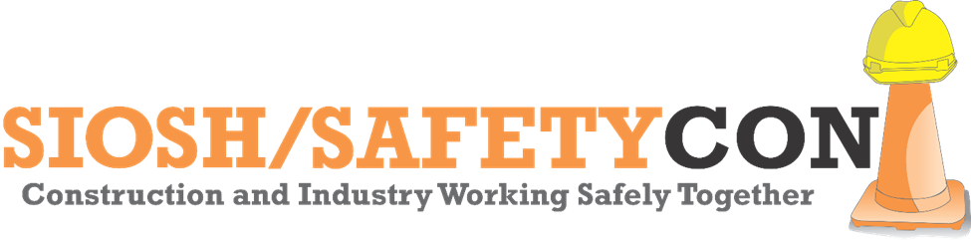
-GENERAL INDUSTRY-

Nomination Form
SIOSH/SAFETYCON AWARD FOR CONTRIBUTIONS IN HEALTH & SAFETY

Award to be presented at the Annual SIOSH/SAFETYCON Day Conference on January 27, 2020

Eligible companies must be located within the southern 39 counties of Illinois. Nomination Forms Accepted Through December 31, 2019, by Submitting to:

Lori Amerman, IMEC
SIOSH/SAFETYCON DAY Planning Committee
618-751-2886
lamerman@imec.org

General Information
Name of Organization

Contact Name

Contact Phone

Contact Email

Brief Description of
Organization Nominated

Injury & Illness Rates
Year | Employee Hours Worked | Total # of OSHA Recordable Cases | Total # of OSHA Recordable Cases Involving Days Away from Work, Restricted Activity, or Job Transfer
2017

2018

Total

Leadership & Contributions
Briefly Explain Leadership and Contributions to the Workforce and Safety & Health Community

(Support of Stand-Downs, Initiatives, VPP, Participation in Alliances, Professional Memberships, Association Memberships, Publications, Presentations, Mentoring, Committee Participation, Conference Attendance, etc.)

Regulatory Violations
Has the Nominated Organization Had Any
Regulatory Violations Over
the Last 12 – 18 Months?

If so, Briefly Explain

Safety & Health Program Practices
General Industry  Core Elements | Attach a Brief Description  Examples May Include
- Management Leadership | - Senior Leadership Commitment  - Responsibilities of Managers and Supervisors  - Resource Allocation  - Accountability
- Worker Participation | - Worker & Representative Involvement  - Safety Committees, Teams, BBS Initiatives  - Lines and Means of Communication
- Hazard Identification | - Routine & Periodic Inspection Mechanisms  - Procedures to Identify Hazards  - Emergency Procedures  - Incident Investigations
- Hazard Prevention & Control | - Formal Safety Program  - Engineering Solutions  - Work Practices, SOPs, Administrative Controls  - PPE Assessments & Utilization
- Education & Training | - Hazard Recognition Training  - Worker Training & Responsibilities  - Senior Leadership, Managers, Supervisor Training
- Contractors | - Contractor Screening/Evaluation & Oversight  - Communication of Host Site Hazards  - Work Coordination
- Program Evaluation | - Hazard Tracking, Prioritization, Verification  - Periodic Review of Safety Program Performance  - Identified Opportunities and Improvements

Nomination Submittal
Thank you for your nomination and commitment to Occupational Safety & Health in southern Illinois. Through submittal of this Application, the Nominator affirms the information herein is valid and accurate to the best of their knowledge, and consents to the Terms & Application Review provided below.

Nominator Name

Nominator Phone

Nominator Email

Terms & Application Review
Applications will be reviewed by the Advisory Board of the American Allied Safety Council (AASC) or appointed designees of the SIOSH/SAFETYCON Day Planning Committee. Award recipients will be notified as soon as reasonably practical to make necessary arrangements for the award ceremony.

